Integration of a Pick-and-Place Robot
By
GROUP 10
Gerald Lambert : 200120665
(Gene) Jun Li : 301152342
Ferry Tanjaya : 301215346
Guninder Malhi : 301228588

B.Sc., Simon Fraser University, August 2016
Project Report Submitted in Partial Fulfillment of the
Requirements for Mechatronics Design II MSE312
School of Mechatronic Systems Engineering
Faculty of Applied Science
© Gerald Lambert, Gene Li, Ferry Tanjaya, Guninder Malhi 2016
SIMON FRASER UNIVERSITY
Summer 2016
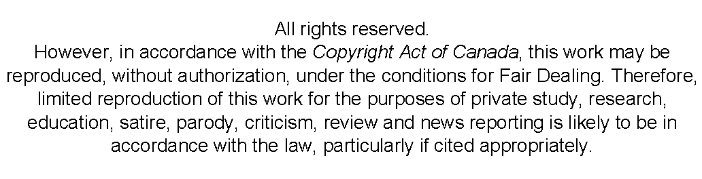

Abstract
This report describes the process of system integration, the PID values for the system were found by running simulations in SIMULINK. System integration involved moving the robotic arm from one position to another and at the same time picking up the magnet and dropping at the second location. The constraints included staying under five-degree overshoot and finishing the whole process of dropping magnet in the shortest time possible. We ended up using a PID controller for both picking and dropping the magnet. As for the conditions, we ended up using cases to pick and place the magnet. Cases ensured that the robotic arm picked up (and dropped off) the magnet only when the acceleration and velocity was zero and the error was less than five. The system was able to complete the given task satisfying the constraints of overshoot and time.

Table of Contents
Abstract ii
Table of Contents iii
List of Tables v
List of Figures vi
List of Acronyms vii
Glossary viii
Preface or Executive Summary or Introductory Image ix
Introduction 1
Chapter 1 System Level Design 2
Chapter 2 Mechanical Design 6
2.1 Truss design 6
2.2 Truss selection 7
Chapter 3 Electrical Design 8
3.1 Motor Driver 8
3.2 Opto-isolator 9
3.3 Electromagnetic circuit 9
3.4 Analysis 10
Chapter 4 Controller design 11
4.1 Lookup table block 11
4.2 Motor PWM signals 11
4.3 PWM for magnet 13
4.4 PID block 13
4.5 Decoder gain 14
4.6 Data Memory 15
4.7 Initial Start 15
4.8 Turn ON the magnet when at the position 15
4.9 Turn OFF the magnet when at the position 16
4.10 Cases 17
4.11 Reduce the error 18
4.12 Differentiate PID value with or without puck 18
4.13 Writing the value to data memory 19
4.14 Read the value from data memory 20
Chapter 5 Simulation and Experimental Demonstration Results 21
Conclusion 24
References 25
Appendix 26

List of Tables
Table 1: Decision Matrix 7
Table 2: PID controller for simulation 21
Table 3: PID for experimental 22
Table 4: Total time for experimental 22
Table 5: Overshoot for experimental 23

List of Figures
Figure 1: Truss mounted on Motor 2
Figure 2: Electric circuit 3
Figure 3: Simulation in MATLAB simulink 3
Figure 4: Sensoray 626 4
Figure 5: Diagram of the connection 4
Figure 6: Flow Chart 5
Figure 7: Truss 1 design 6
Figure 8: Truss 2 design 6
Figure 9: Truss 3 design 7
Figure 10: Motor driver performance 8
Figure 11: electromagnetic circuit 9
Figure 12: Lookup table 11
Figure 13: PWM generator setup 12
Figure 14: PWM to the motor 12
Figure 15:Magnet PWM setup 13
Figure 16:PID controller setup 14
Figure 17: Decoder gain 14
Figure 18: Data memory 15
Figure 19: Initial start method 15
Figure 20: Block to pick up the magnet 16
Figure 21: Acceleration and velocity 16
Figure 22:Block to drop the magnet 17
Figure 23: Cases 17
Figure 24. Error of the system 18
Figure 25: Logical block PID without puck 19
Figure 26:Logical block PID with puck 19
Figure 27: writing into memory 19
Figure 28: Read value from memory 20

List of Acronyms
MOSFET | metal–oxide–semiconductor field-effect transistor
SFU  PWM | Simon Fraser University  Pulse Width Modulation

Glossary
MOSFET  PWM | type of transistor used for amplifying or switching electronic signals. (Wikipedia, 2016).  a modulation technique used to encode a message into a pulsing signal. (Wikipedia, 2009)
Motor Driver  Opto-isolator  PID | Electric component that used to drive motor  Electric components that used to control the current and voltage input  A type of controller that being use to control the system

Preface or Executive Summary or Introductory Image
This report is a detailed walk through of the whole process behind the pick and place robotic arm. Starting of with mechanical design, three truss designs were proposed and one was selected to go further with the project. After designing and constructing the truss, the electrical part of the project came into play. Electrical circuit was designed to control the direction and speed of the motor using PWM. Then the electrical circuit was copied on to a PCB. After completing the electrical part, control part involved figuring out the PID values of the system using SIMULINK, which would further be utilized in the integration of the whole system. The values obtained from the control part deduced that a PD system would best fit the requirements. Final integration part involved putting the whole system together and testing the experimental values to actually run the system. Sensoray 626 was utilized to model the simulation in real time. Eventually, the system was able to achieve the required results within the time constraint; including the pick and place of the puck from the assigned positions.

Introduction
Today with technology progressively growing in our society mechatronic products are becoming increasingly popular and integrated into our everyday lives. The integration portion of this project gave us a chance to design, and develop software to control our robotic truss arm using SIMULINK. The challenge for this task was to have the arm move from a starting position (0 degrees) to a “pickup” location at -45 degrees where the electromagnet would pick up a metal block, and then drop it 45 degrees relative to starting position, before returning back to the home position.
The rotational movement would be powered by an electronics circuit. This circuit also powers the electromagnet that would allow the arm to pick up and drop off the metal block. Additionally, we developed a mathematical model on feedback control which provided the working nature of the system. In order to have successful movement we were required to obtain the quickest time while maintaining an overshoot of less than 5 degrees. For accuracy we incorporated a PD or potentially a PID controller in our Truss system Simulink model to achieve the desired positions so we have the highest velocities and limiting the possibility of overshoots. As seen in Figure 1 Our Robotic Arm truss is at a position of +/-45 degrees relative to the home position while picking up the magnet and dropping it.

Chapter 1
System Level Design
The project of the course is about constructed cantilever arm and programmed it to pick and place the puck from point to point in fast time. The task is divided by four portion, mechanical, electrical, control system and integration. In the mechanical part, we constructed truss of the cantilever arm. The restriction of the size of cantilever truss is given which is 30 cm. The inertia and buckling analysis will be performed in this section. From the analysis that we had, the lighter the mass of the truss will give you lower inertia which will increase the speed of the arm to move from one point to point.
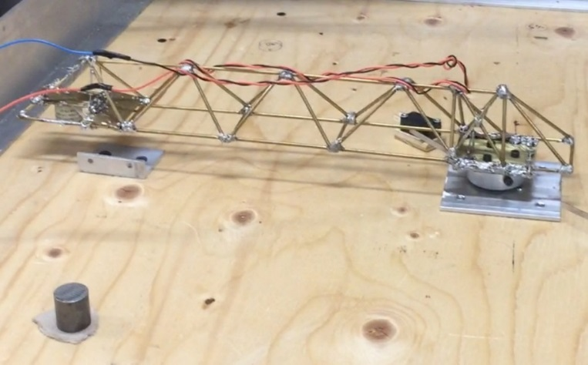
Figure 1: Truss mounted on Motor

To move from one point to point, motor is needed and to drive the motor, motor driver circuit is needed. So in the electrical part, we are constructed the circuit of the motor driver and also electromagnet circuit to pick up the puck. The circuit need to be tested first on bread board before solder it on proto board. To test the circuit, we used a function generator to generate a PWM wave to the input of the motor driver and output connected to the motor. We did the same method for electromagnetic circuit. From the testing we observe that our circuit is active low circuit.
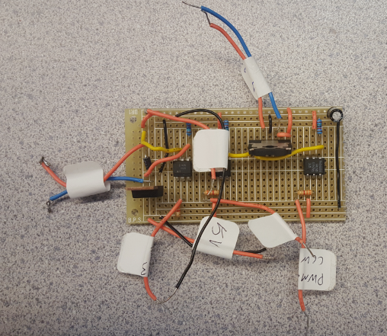
Figure 2: Electric circuit

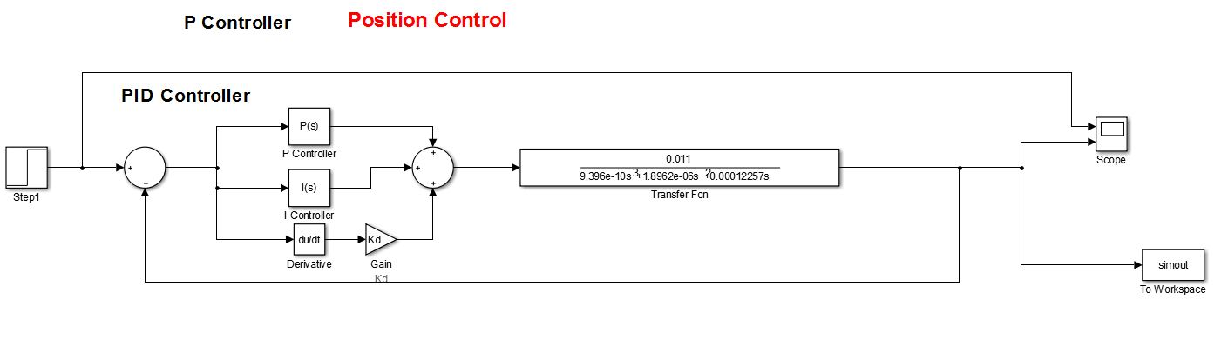
In the next portion of the task is control system. In this part we simulate the control system in MATLAB Simulink to observe the output of the system. The inertia from the truss needed to be included in the model as well as the data from the motor. From this portion, we observe the performance of the system by using P, PD, PI and PID controller and choose which one is the best for our controller to pick and place the puck.
Figure 3: Simulation in MATLAB simulink

In the last portion is about integration in which you combine the truss, circuit and control system simulation into one. In the integration part, we are using a MATLAB Simulink that connected to Sensoray 626 to program our simulation.
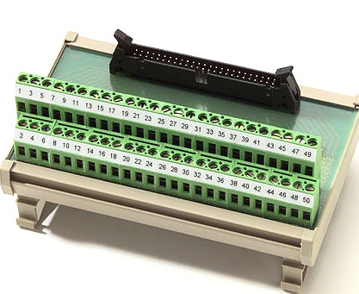
Figure 4: Sensoray 626
Below here is the terminal block connection circuits to connect from motor to sensoray 626.
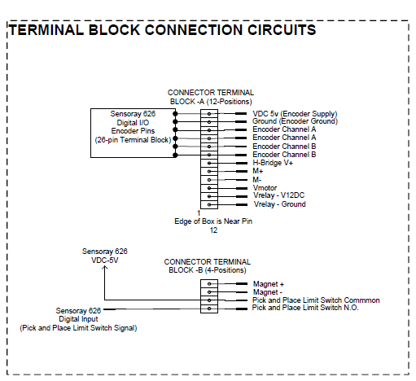
Figure 5: Diagram of the connection

Below here is the flowchart of the system process:
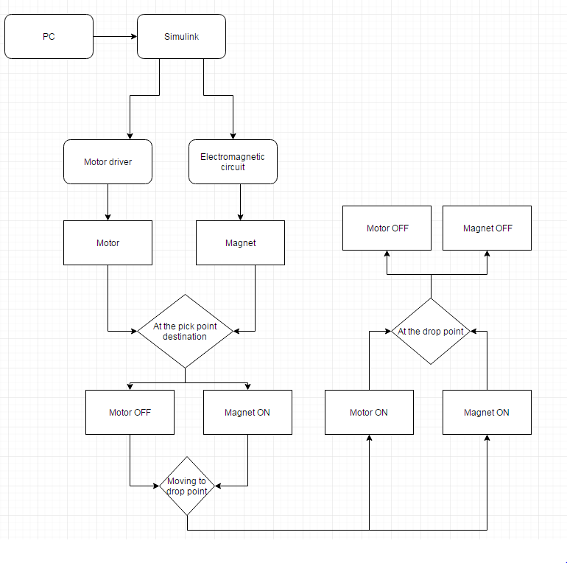
Figure 6: Flow Chart

Chapter 2
Mechanical Design

Truss design
As required by the project description, our team came up with three different designs to choose from. The first design involves triangular shape all around with a rectangular base as shown in the figure below:
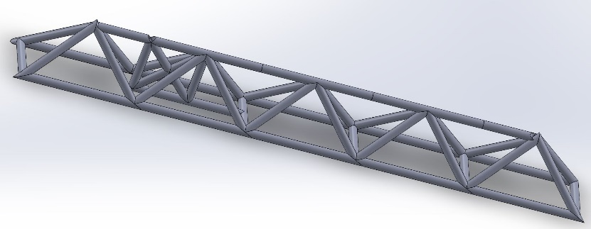
Figure 7: Truss 1 design
This design was chosen to go further with our project as it showed most promising results. The second design we came up with resembled to more of a rectangular structure as shown here:
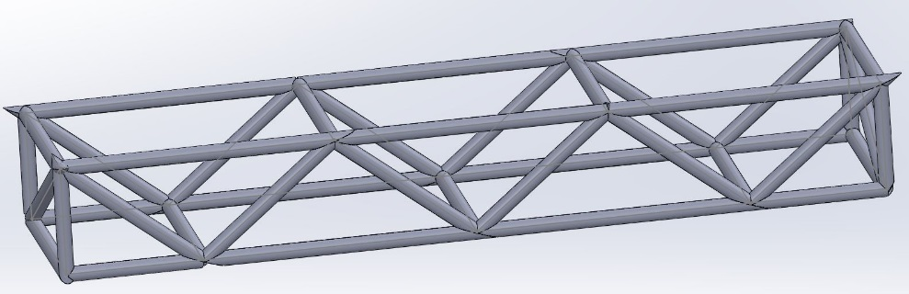
Figure 8: Truss 2 design
Just to clarify, all the members lengthwise are 5 centimeters in length it is just that the software was not able to display the soldering. As we can see that the square structures at the end face cannot withstand as much load as compared to the design before, so we chose the previous design. The last design (Figure 6) proposed by our team composed of a mixture or hexagon and square geometries. This design was not chosen for the reason that it would have involved more complex soldering and more careful handling which could have been an issue given the testing it had to go through later.
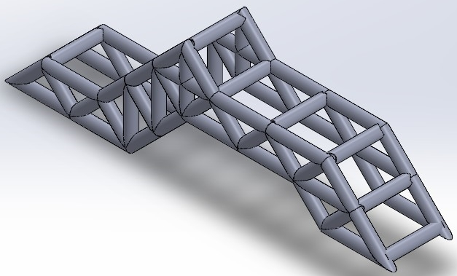
Figure 9: Truss 3 design

Truss selection
More clear understanding of our design selection can be gained from the decision matrix.
 | Design 1 | Design 2 | Design 3
Load | 9 | 6 | 7
Safety Factor | 8 | 7 | 5
Deflection Factor | 8 | 8 | 7
Final Score | 8.33 | 7 | 6.33
Table 1: Decision Matrix
Apart from our choice to go with design 1, the decision matrix also supported our decision. Total inertia of the truss is 0.0021 kgm²

Chapter 3
Electrical Design
In this part of the lab we are able to design and build the power interface circuit for driving the DC motor that will rotate the mechanical arm at a certain angle; the arm is equipped with an electromagnetic gripper. The objectives of this project are to design and build the electronic drive circuit using parts such as MOSFETs, Bipolar Junction Transistors, and H-bridge Integrated Circuitry. Afterwards, we will practice electronic test procedures using test equipment such as breadboards, oscilloscopes, power supplies and multi-meters to build a working power electronic driver on a prototyping board.

Motor Driver
DC motors have only positive and negative leads, when connected to a DC voltage source; the motor will rotate in one direction. To change the motor in opposite direction, the polarity must be reversed. If we want the motor to rotate in 2 directions, one option is to use 2 transistors and another option is use a H-bridge driver. In our project we are using the H-bridge driver motor. Figure below shows how the H-bridge driver circuit is used to rotate the motor in 2 directions.
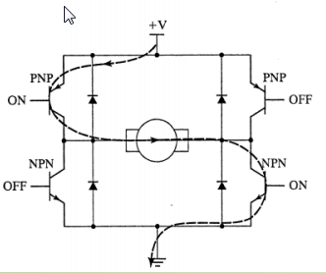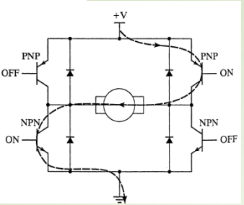
Figure 10: Motor driver performance
Braking can be performed by:
- turning ON both the upper transistors while turning OFF both the lower ones
- turning OFF both upper transistors while turning ON both lower ones
If we looked at the H-bridge diagram, there is a kickback diode used. It is because when we switch off the supply across the inductor the voltage across the inductor spikes up due to the sudden change in current and due to the property of an inductor; it tries to keep the current constant and hence, pulls more charge which leads to the voltage spiking. In practice voltage spikes are very dangerous for semiconductor circuits so a diode is used across it in the opposite the direction of normal current flow to suppress inductive kickback.

Opto-isolator
The opto-isolator is used to transfer electrical signals between two isolated circuits by using light. The opto-isolator prevents high voltages affecting the system receiving the signal. The PWM will be flow to opto-isolator and the intensity of light will adjust how much voltage input is needed from the PWM. Then it will be fed into a driver which gives the output to motor. Our motor driver circuit is an active low circuit.

Electromagnetic circuit
The concept of driving the electromagnet drive circuit is almost the same as the motor drive except that we drive it with a MOSFET. PWM is routinely used for continuous intensity control of electromagnetic loads. A MOSFET is used to adjust the flow of electric charges by adjusting the flow of the charges. A higher PWM will make the electromagnet stronger for active high, but our circuit is active low circuit. The diode here acts as a kickback diode. For R1 we used 15KOhm resistor and for RB we used a 3.3KOhm resistor.
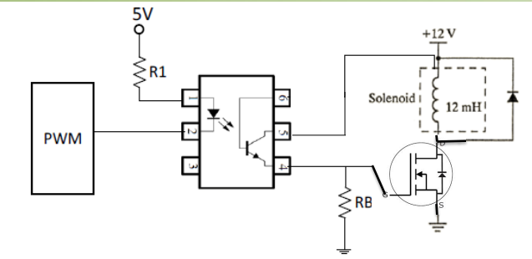
Figure 11: electromagnetic circuit

Analysis
A very low frequency also affects the speed of the motor or the intensity of magnet. As we all know, higher frequencies produce a smaller period in the signal. And, we know that the duty cycle is the ratio of the on-time and total time in a period. Therefore, at high frequencies, the motor turns on and off at a very short time (in millisecond) such that it does not allow the motor to turn off to the point that it is noticeable. As a result, the motor outputs the average value of the speed. On the other hand, a high frequency results in a long period which it does not give the motor enough time to reach its peak current or to charge up its current enough to break the friction between the stator and rotor. This is known in industry as dead-band frequency due to mechanical limitation.

Chapter 4
Controller design
For the last portion of project, we need to create a program in MATLAB Simulink that connected through Ni-DAQ. In the MATLAB Simulink, there would be a significant program that need to be make and adjusted to our truss and system needs.

Lookup table block
Lookup table block is the interpolation between the input and the output. In some cases, the look up table is needed to approximate the gain needed. For example, if you set the position to be 45 degrees and decoder shown value of 44 degrees, to achieve that 1 degree, lookup table refer the system to give just small portion of the gain so that overshoot could be reduced. Also if we are 45 degrees, the lookup table will refer the system to stop. Lookup table block is act as a dead-band for the system. In our system, we don’t implement lookup table since our system is pretty stable already.
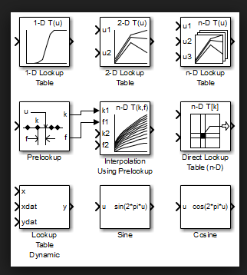
Figure 12: Lookup table

Motor PWM signals
In order to run the motor, we need to implement Pulse Width Modulation to manifest duty cycle in the physical motor. To generate the PWM signal to the motor, we need to generate signal by using signal generator and compare that with the step input from the input. The output will be square wave and will be feed in to DC motor. The image below shown how the we construct the block. We use sawtooth signal from the generator and set the amplitude to be 5V. We set the frequency to be 400Hz. Too high frequency results in a long period which it does not give the motor enough time to reach its peak current or to charge up its current enough to break the friction between the stator and rotor. This is known in industry as dead-band frequency due to mechanical limitation.
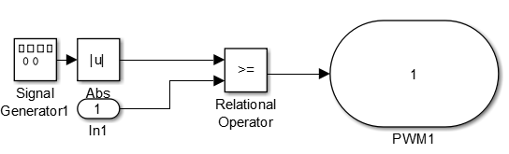
Figure 13: PWM generator setup
We use 2 PWM, one for the motor goes in clockwise and the other one for motor goes in anti-clock wise. The switch there is to compare the value with 0, if the signal is greater that 0, that means that the signal from one of the PWM block will feed in into Motor driver and the other one will be off. The digital output is connected to input motor driver and output motor driver connected to DC motor. Since our circuit is in active low, that means will be off if there is a positive voltage, so we feed in 1 from the constant to the digital output. Constant 1 in our system represent active high.
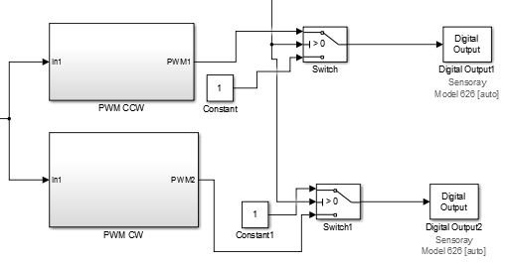
Figure 14: PWM to the motor

PWM for magnet
The idea of PWM for magnet is almost the same as the PWM for motor. The circuit of the magnet also is in active low. By feeding it 1 will make it the magnet OFF. The PWM generator that we used is for convert the input value to duty cycle. We set the current from the generator to be 500 mA, from here we realize that if we set into full PWM for magnet (0% duty cycle), the magnet will drain a more current than the DC motor and the result is that the motor could not rotate. To avoid that, we only feed in 50% of duty cycle and the system work well.
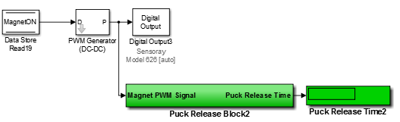
Figure 15:Magnet PWM setup

PID block
Below here is the setup block for PID controller. To avoid the error of integral accumulate, we use saturation block after the integration controller to limit down the value of integral gain. We set it to 0.5 and 1 boundaries. We realized that the greater Proportional gain in the system will make the system overshoot and oscillate a lot. To reduced the overshoot and oscillation, we increased the derivative gain but in result the system slowed down. We also realize that our system works well with PD controller. Since our system always at the position that we wanted, the I gain is not necessary used.

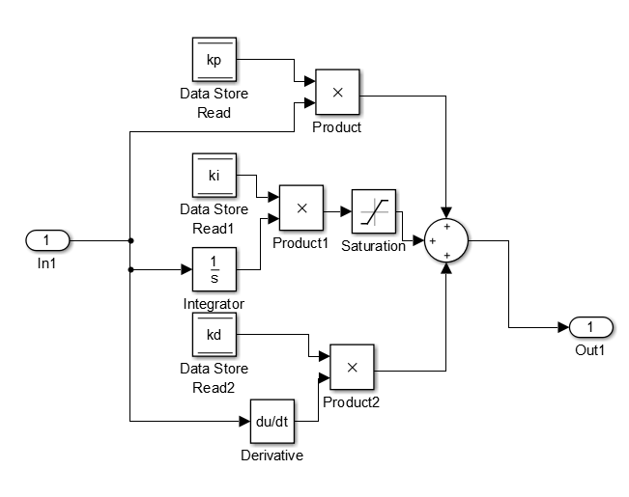
Figure 16:PID controller setup

Decoder gain
The decoder is responsible for controlling the speed and direction of the motor. In our cases the decoder is used to controlling the direction of the motor. The gain of decoder in our DC motor is 360/9600. It means that each 26.67 line represent 1 degree. When the motor start rotates, the decoder will start reading the line and stop reading when it reaches desire position. We realize that our motor gain decoder is not 360/9600, because when we rotate the motor for one rotation, it shows 420 degrees. It happens because the backlash error of the gear. To avoid that happen, we multiply it by 0.765 to get 360 degrees.
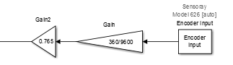
Figure 17: Decoder gain

Data Memory
We used data memory to store the value and process the value back to the system.
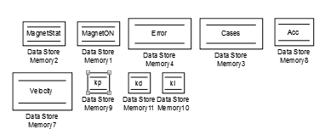
Figure 18: Data memory

Initial Start
We used switch to change the state of the input. Because from the start, the Data memory block will show 0, then we use that opportunity to give an output the initial point to where is the magnet is. Then after the truss is at the magnet position, the MagnetStat data memory will change to 1 by feeding in with if statement block and the switch will move to drop point step point.
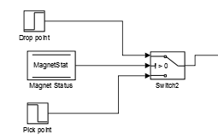
Figure 19: Initial start method

Turn ON the magnet when at the position
Below here is construction of the program when the truss at the top of magnet. We use the acceleration condition and error condition. So our logic is when the acceleration of the system is 0 and when the error is within the boundary, the magnet should be ON. The acceleration and velocity could be done by taking the derivative of the position and we can get the position of the motor from DC motor decoder gain.
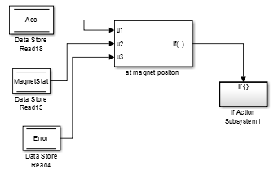
Figure 20: Block to pick up the magnet

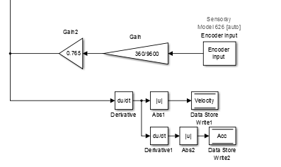
Figure 21: Acceleration and velocity

Turn OFF the magnet when at the position
The logic behind this is the same as pick up magnet. We used the acceleration, velocity and error of the system to drop the magnet by turn it off.

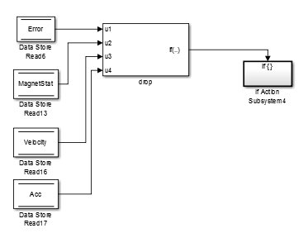
Figure 22:Block to drop the magnet

Cases
The cases block here is used to communicate with the system to turn ON or turn OFF the magnet. If one of the cases is chosen, it will executed what inside the switch case action.
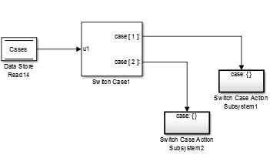
Figure 23: Cases

Reduce the error
Below here is the block limit down the error of the degree in the system. We want all the possible error being process and we want to compare the magnitude of the error, so that we take the absolute value. If the error is greater than the 3 degrees, the error will be process and the gain will be feed in DC motor and it will adjust to the position. And if the error is less than 3 degrees, then it means that it’s about at the position. So the PID will not process the error and the motor will stop rotate.

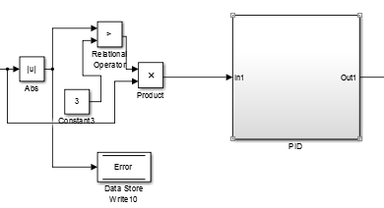
Figure 24. Error of the system

Differentiate PID value with or without puck
To differentiate the PID value between truss with puck and without puck, we need to write PID value that we want to feed in into PID memory in the if action subsystem block. We used MagnetStat data memory to change the state of PID value. So when MagnetStat is 0 and when the error is greater than 0, mean that the truss is not carrying puck. When the MagnetStat is 1, it means that the truss in carrying puck and the magnet is ON. If the conditional is met, the if action subsystem will be process.

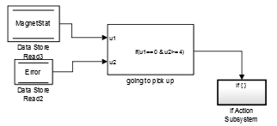
Figure 25: Logical block PID without puck
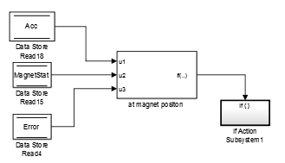
Figure 26:Logical block PID with puck

Writing the value to data memory
Below here is how we fed in the value to memory. If the conditional is met, the value inside if action subsystem block below here will be executed.
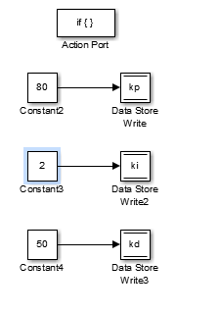
Figure 27: writing into memory

Read the value from data memory
Below here is shown how we read the value from data memory, and we used it for PID. The data was stored in memory and by calling the read it will give an output of the last data stored.
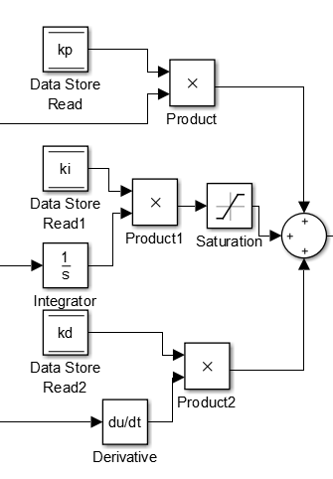
Figure 28: Read value from memory

Chapter 5
Simulation and Experimental Demonstration Results
Based on simulation that we had to move to from original position to 45 degree, we found that using P controller will give you much overshoot. (P = 20, I =0.05, D = 0.01)
Table 2: PID controller for simulation
Position | 45
Controller | Rise Time (s) | Settling Time (s) | Overshoot (%)
P | 0.1603 | Undefined | 99.0322
PD | 0.0621 | 0.6614 | 5
PI | Undefined | Undefined | Undefined
PID | 0.062 | 0.7363 | 5.185
When we tested the value that we used for simulation, we found that the P value is good enough but it has a lot of oscillation. We also found that the value that we used for simulation is not matched with the experimental. One of the reason that make it different is the feedback loop for simulation we assumed is 1, but in experiment the value of feedback loop is the gain of controller. We observe that the motor itself could affect the performance of PID controller especially the backlash of the gear of the motor. The board also is not flat enough, sometimes when moving the puck, the friction occur between puck and board.
By tweaking the value of PID, we could achieve the better performance. We also found out that using PID and PD controller does not really make a large different on the system. Increasing the D gain will reduce the oscillation of the system. But if the D gain is too big, the truss could not reach the final value.

For this experiment, we used:
Table 3: PID for experimental
With Puck | Without Puck
P=80 | P=60
I=2 | I=2
D=65 | D=55

The time that we had when moving from -45 degrees to 135 degrees:
Table 4: Total time for experimental
Trial | Total Time (approximately)
1 | 2.4 s
2 | 2.68 s
3 | 2.7 s

Table 5: Overshoot for experimental
Trial | Overshoot (degree) at 45 degrees
1 | 2 degrees
2 | 2 degrees
3 | 3 degrees

Conclusion
After the successful completion of the integration section, our robotic arm design and completion of the required design parameters; we looked back on the project on a whole and really understood the fundamentals that had to come together for it all to function. In the design and implementation in the mechanical and electronics and finally in setting up the foundation for our control and integration sections we gained plenty of hands-on practical experience. Moreover, the SIMULINK software taught us the fundamentals of the virtual environment in interfacing with the robotic arm so it performed optimally. Time was spent figuring out the type of controller to use, which SIMULINK blocks would perform best, how to optimize PWM to achieve actuation on the DC motor response which we were satisfied with. The most tedious part was tuning the controller gain values for (K_{p}, K_{I} and K_{d}) to further improve the performance of our robot arm. However, since engineering is never perfect we experienced countless failures and after numerous testing we adapted and found solutions. This course was an imperative project for students as it provided credible skills for mechatronic systems engineering. In our experience, we realized the scale of this project and the difficulty in optimizing the speed and overshoot performance characteristics more so in the integration part section, as all aspects of the project came together. For future practices dealing with control systems we hope to work on more practical projects to improve and apply our knowledge of integration to control feedback systems. The video of the performance could be found from the link: "https://www.dropbox.com/s/esgiwby0egt856m/File%202016-08-08%2C%208%2018%2013%20PM.mov?dl=0"

References
[1] | A. Marzouk, MSE 312 Mechatronics Desing II Control Project, Surrey, 2016.
[2] | "PWM," [Online]. Available: https://en.wikipedia.org/wiki/Pulse-width_modulation. [Accessed 7 8 2016].
[3] | "MOSFET," [Online]. Available: https://en.wikipedia.org/wiki/MOSFET. [Accessed 7 8 2016].

Appendix
